
Instructions for HP MFP machines
Step 1: Go to the printer and click on the screen to turn it on.
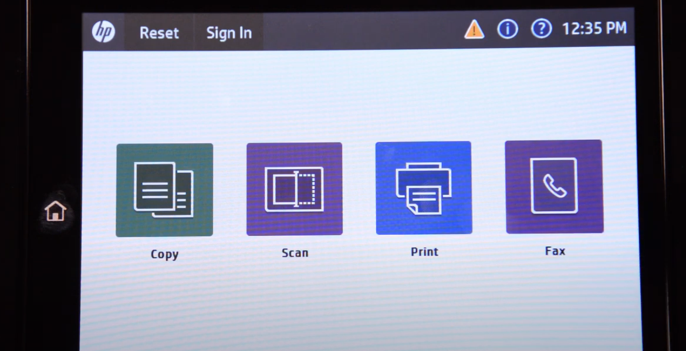
Step 2: Swipe to the right once and click “reports”.
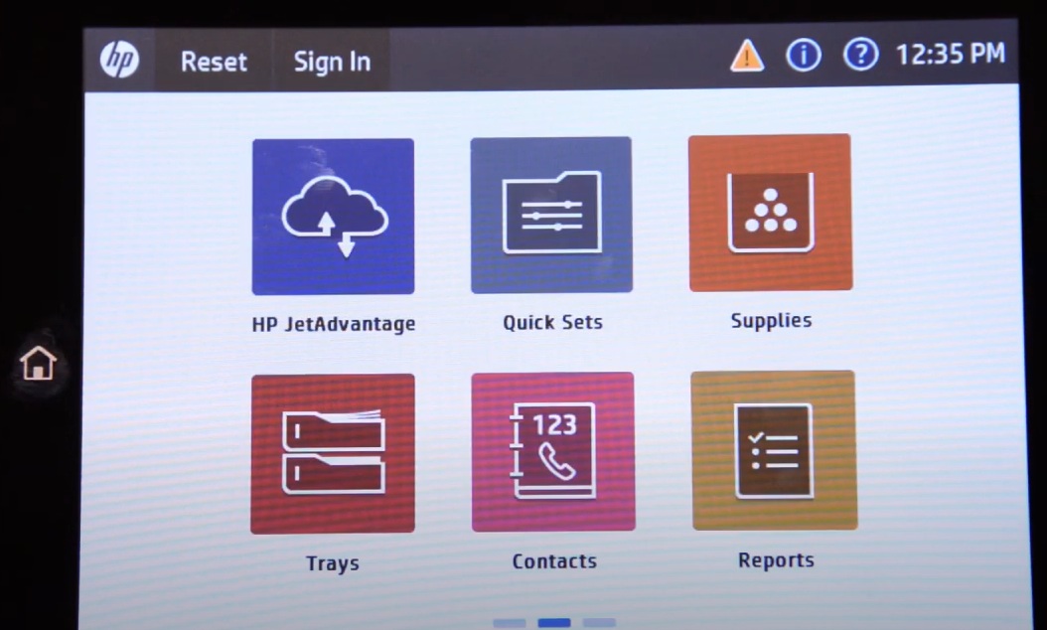
Step 3: Click configuration/status page.
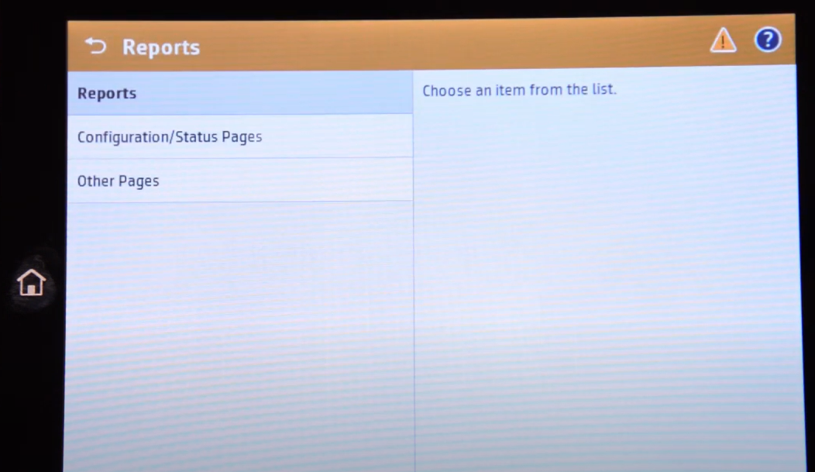
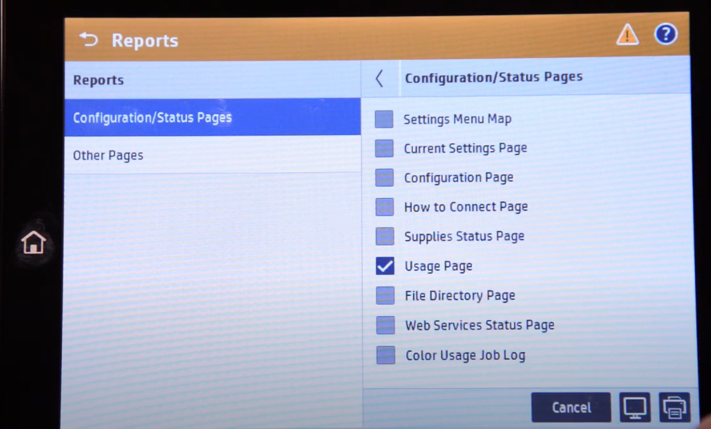
Step 4: Scroll to the bottom of the page and click “usage page.” Then click the print icon to print out the page.
(There are some usage page examples below) The highlighted number on the usage page pictured below are the meter reads ImageNet Consulting uses to keep track of printing on the machine.

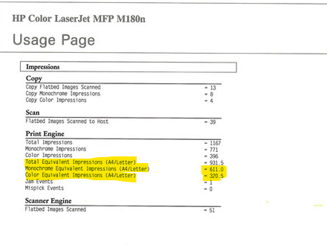

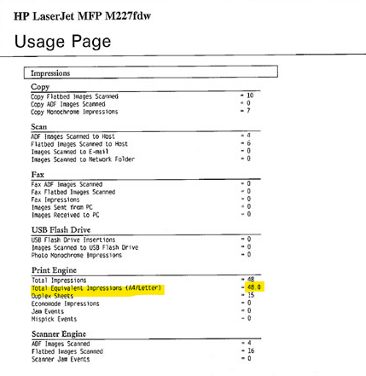

The number highlighted is what can be entered in the link provided via email or provided over the phone to a meters specialist.
Please send meters and/or scan the usage page to meters@imagenet.com .
If you need further assistance or have any questions call 1-800-937-2647 and press 9 for meters or 0 for the operator to direct you.

