

Instructions for Kyocera ECOSYS M2540dw

Step 1: Go to the printer and click counter on the top left.

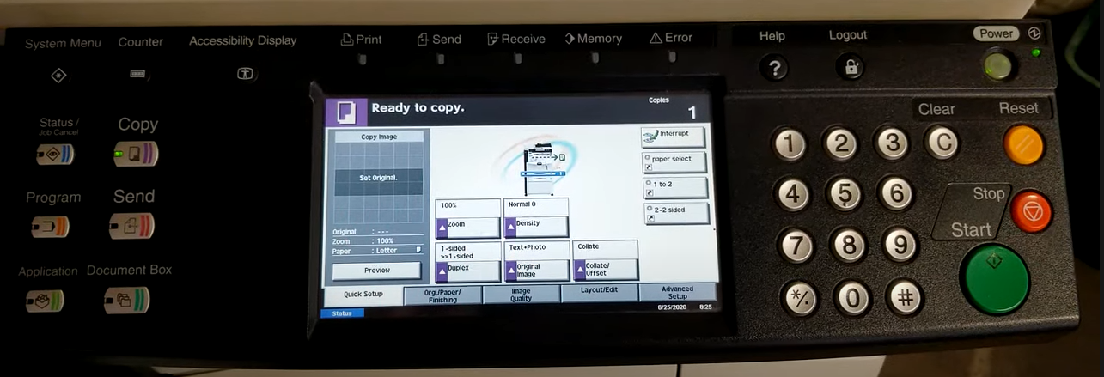
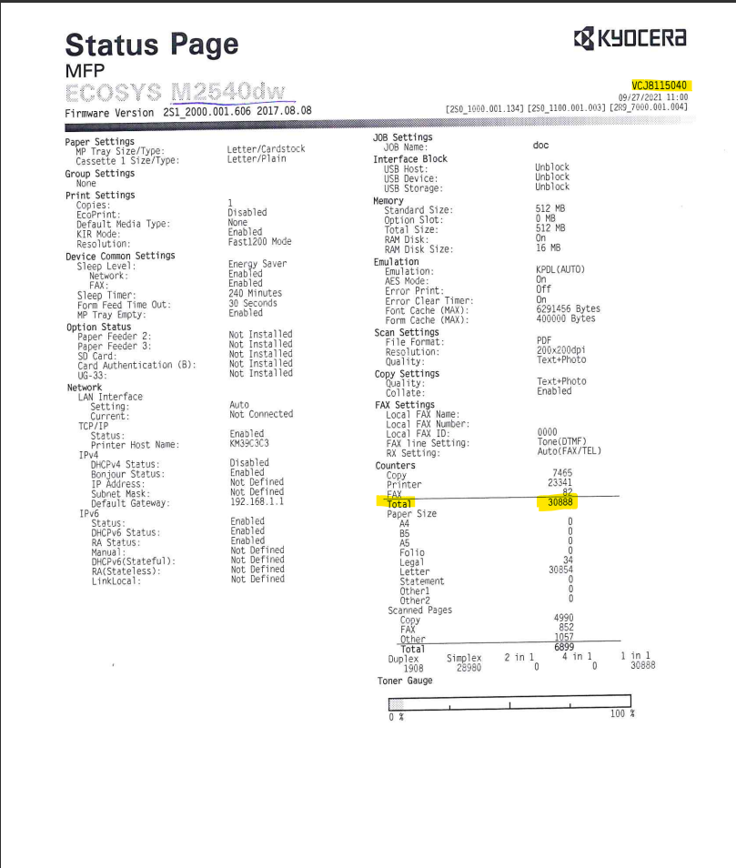
The highlighted number on the counter pictured to the left is the meter reads ImageNet Consulting uses to keep track of printing on the machine.
The numbers highlighted on the bottom are what can be entered in the link provided via email or provided over the phone to a meters specialist.
Please send meters and or scan the counter page to meters@imagenet.com .
If you need further assistance or have any questions call 1-800-937-2647 and press 9 for meters or 0 for the operator to direct you.

